DBMS Technical Task
Dhanalakshmi K
E25AI110
BSc. Computer Science
With
Artificial Intelligence

Week 1: Requirement Analysis and Customer Database Module

Understanding E-Commerce Business:
An e-commerce platform handles the complete process of online shopping, starting from customers browsing and selecting products to placing orders, making payments, and receiving their purchases. It also helps businesses maintain information about customers, products, orders, payments, and other activities. The following section provides an overview of the business operations, the information required about customers, and the main entities involved in designing the system and database.

Entities:
Entity | Key Attributes | Relationships
Customer | customer_id (PK), name, email, phone,address, registration_date | One-to-Many with Order, Review
Seller | Seller_id (PK), company_name, email, phone, rating, bank_details | One-to-Many with Product
Product | product_id (PK), seller_id (FK), title, description, price, stock_quantity, | Many-to-One with Seller, One-to Many with Review
Order | order_id (PK), customer_id (FK), order_date, status (pending, shipped, delivered, cancelled), total_amount, shipping_address | Many-to-One with Customer, One-to One with Payment, Many-to-Many with Product (via OrderItem)
Payment | payment_id (PK), order_id (FK), payment_method (credit card, UPI, PayPal), status (success, failed, refunded), transaction_id, amount, payment_date | One-to-One with Order
Review | review_id (PK), customer_id (FK), product_id (FK), rating (1–5), comment, created_at | Many-to-One with Customer, Many to-One with Product

CREATE Customer Table:
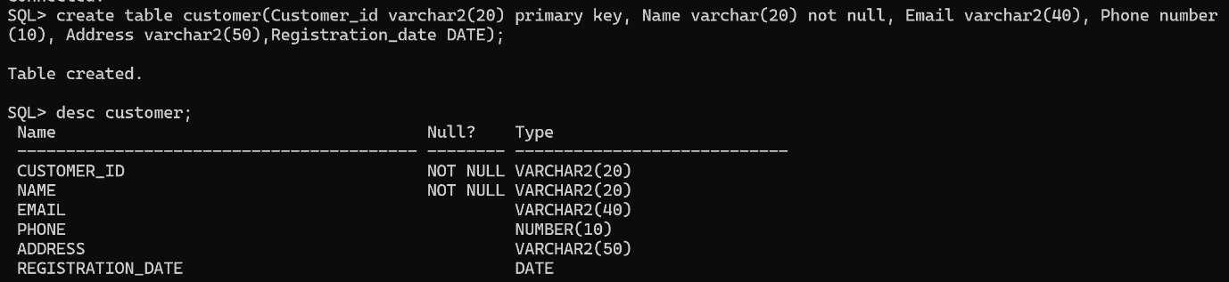

Insert values:
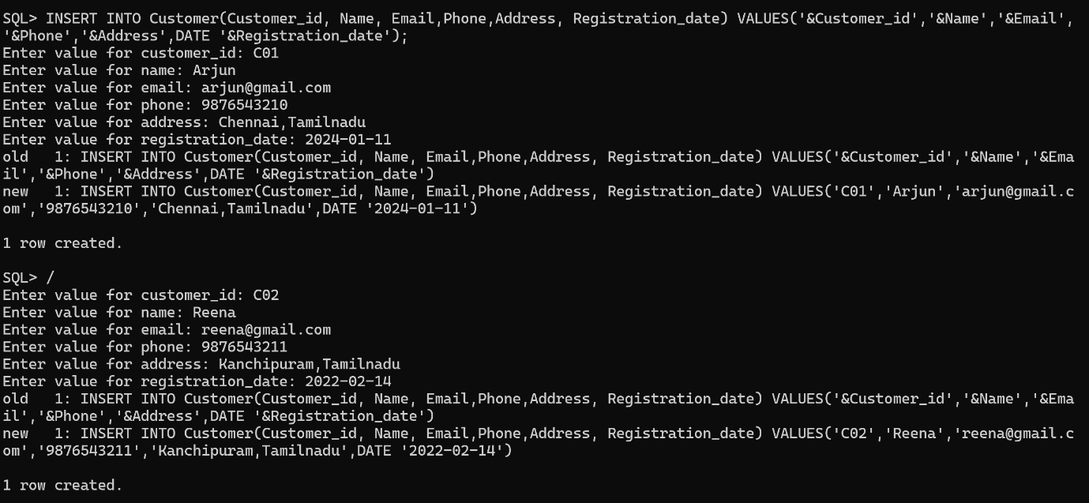
Like this is we can insert many rows as we want.
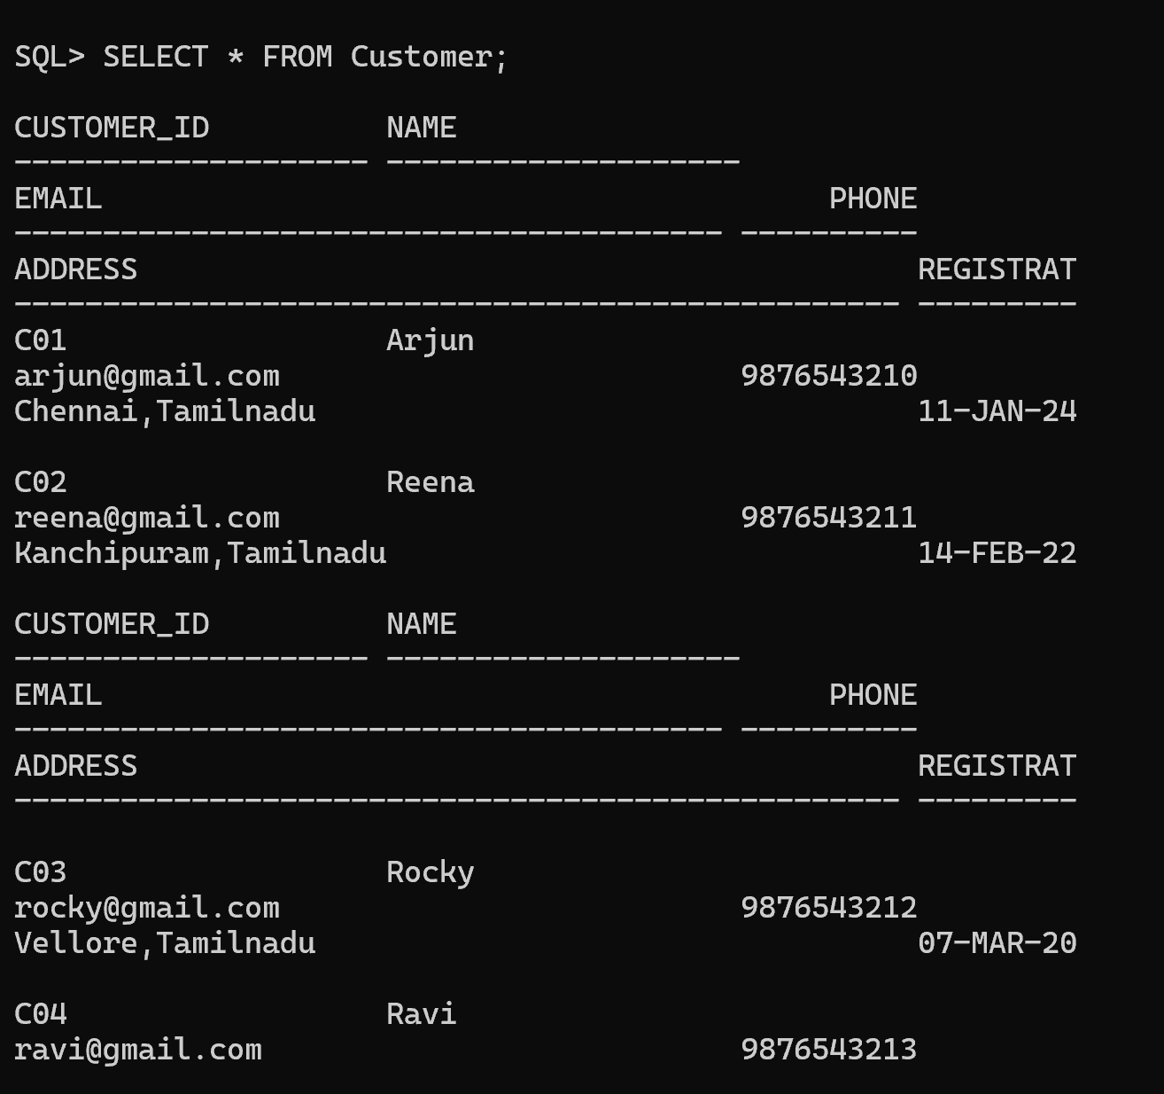

Update and Delete the Record:
